Mental and Conceptual Models, Conceptualizing Interaction:

**Activity 1:** What were some assumptions and claims that Apple made about its Vision Pro Headset? What has been the real-world feedback on the same assumptions and claims? Research and list down. 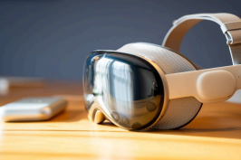

Apple had launched the Apple Vision Pro in late February of 2024 to the audiences of the United States and all over the world. It was introduced to the world in June 2023 during the Apple event. During that, it was told that the Vision Pro is the top-most virtual reality gadget available in the market, beating the Meta glasses as well as the Meta Oculus. It wasn’t just launched as the next augmented reality headset, but it was termed as the world’s first spatial computer.

* Seeing Apple’s ecosystem with all its other devices, such as the Mac, iPad, iPhone, and the Apple Watch, this was considered the next step to spatial computing without the need for a digital screen. Apple’s vision pro could blend seamlessly with the physical world, interacting with their favorite app.
* It was claimed that, unlike Meta Oculus, to control the device, you won’t require external remotes or controllers; you can control it by using the user’s eyes, hands, and voice. Users had to simply look at the element on the virtual screen and select it.
* Being a virtual screen without the use of a monitor, the resolution was claimed to be realistic, as well as packing 23million pixels across two displays. The touch as well as the feel of using the vision pro will feel responsive and non-laggyas compared to other spatial computing devices.
* Vision pro wasn't just claimed to be a spatial computer , but also an immersive entertainment device. It was claimed that due to its awesome vr computing capabilities, it could transform any room into a personal theater or feel like movies shows and screens come to reality with the support of spatial audio and dynamic head tracking.

The real-life feedback of Apple Vision Prowas firstly that the market wasnt ready for this kind of premium devices which cost more than the cost of laptops as well as ipads. The users who were able to afford these devices said it was fun, and the lack of controllers was a major advantage since the person didn’t need to hold anything in the hand and uses gestures to control it. The most exciting feature of the Vision Pro was the virtual reality transformation by changing your own room into a Vr environment, such as the Jupiter planet dinosaur era, etc. This worked excellently and was appreciated by users who frequently used this feature.

If you have a Mac or a device using macOS, Apple Vision Pro was able to monitor its screen and copy that as a form of virtual environment, which could be placed anywhere in the environment. This has been credited as the best feature, as a person traveling in a tight space or working in a tight space can now utilize all the space around them. This feature was the most talked about, along with the virtual environment feature. Another real-world feedback was that if a person is using it for gaming , watching movies , after some duration of use, like 1 to 2 hours , the person felt headaches, dizziness, and discomfort. There was an external battery pack attached to the Vision Pro, which had a battery life of 2 hours at max.Users said that this to limiting of mobility and extended use. In the end, the inclusion of EyeSight and the ability to seamlessly blend the real and digital worlds suggest an underlying assumption that users want a less isolating experience than traditional VR headsets and wish to remain aware of and connected to their physical surroundings.

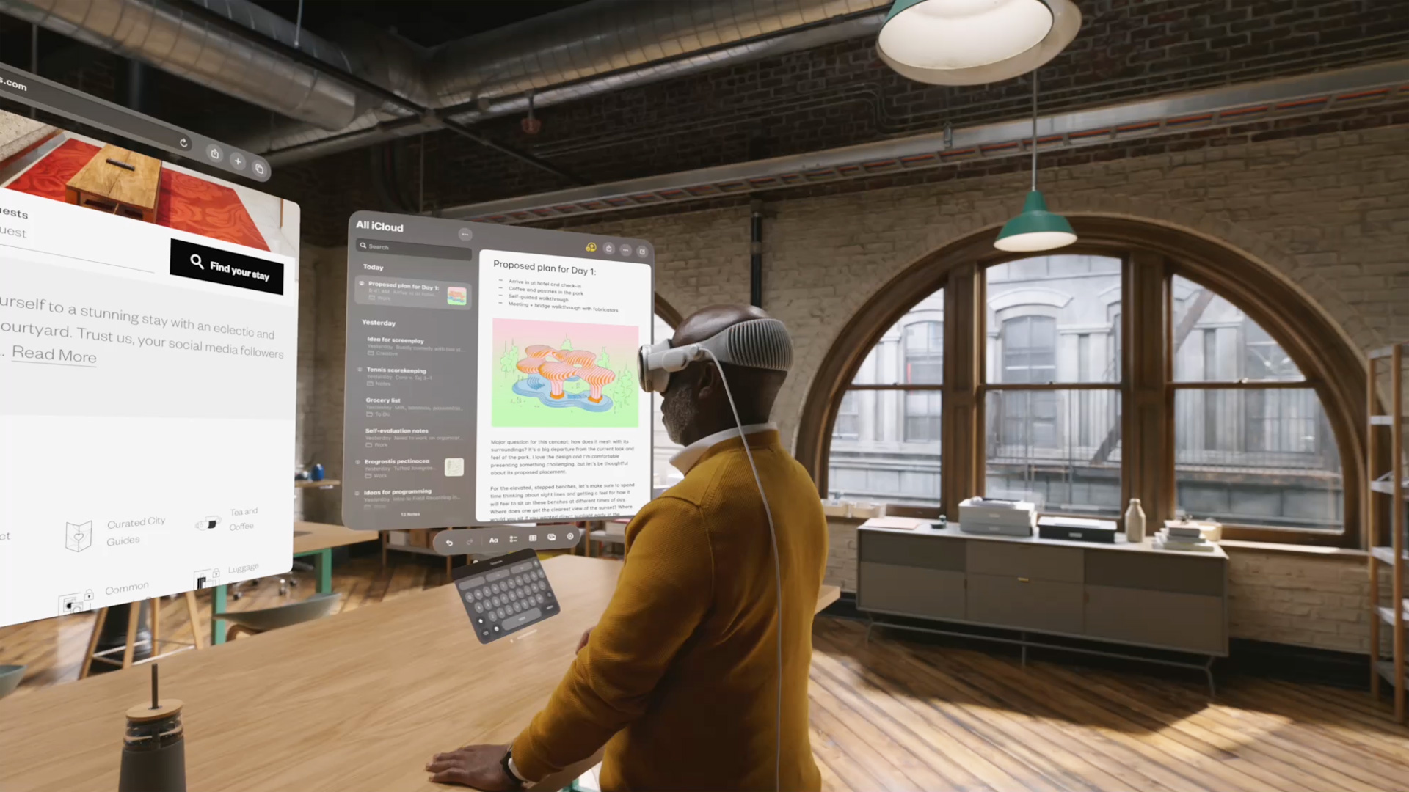

**Activity 2:** What were some assumptions and claims made about the recent AI hardware product - Rabbit r1 AI voice assistant?

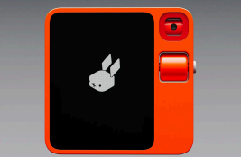

What happened in the real world once it was launched? Research and List down.

Rabbit r1 is your personal assistant in your pocket; it’s a type of AI in the box gadget. A single-button device with a built-in screen for displaying the output, along with a SIM card slot, so that it is portable and can be carried around.

* It also has a Type-C charging port, which makes it the latest in the field. It also has Bluetooth as well as built-in speakers, which can be used to hear the output coming from the device.
* In a functional definition , it is a large action model that was trained to observe and model human interaction. What made it different from a smartphone was that it had unique hardware features like push to talk and rotating camera using computer vision for identifying objects
* The major claim centered around it was for a new paradigm for interacting with digital services. The analog controls give it a kind of universal controller for apps.
* The audio input through voice and the output coming on the screen was considered as the fundamental breakthrough that could reliably execute complex, multi-step actions across diverse and constantly-changing digital interfaces, which current AI assistants cannot do.
* Rabbit r1 also had a built-in camera in the back, which could scan and see the objects being shown to it in real time and answer the questions being asked about it. Like here in the image, the user is asking the rabbit what the type of plant is.
* The large action model in this will take our words, process them, and then convert them into action. It essentially aims to get control and use the app or the permission given to it like a human would.
* A LAM would be able to use services like Amazon, Spotify, Uber and food ordering.
* At last, the device was claimed to be moving away from the complicated Ui Ux designs and the distraction of having hundreds of apps on a smartphone.
* 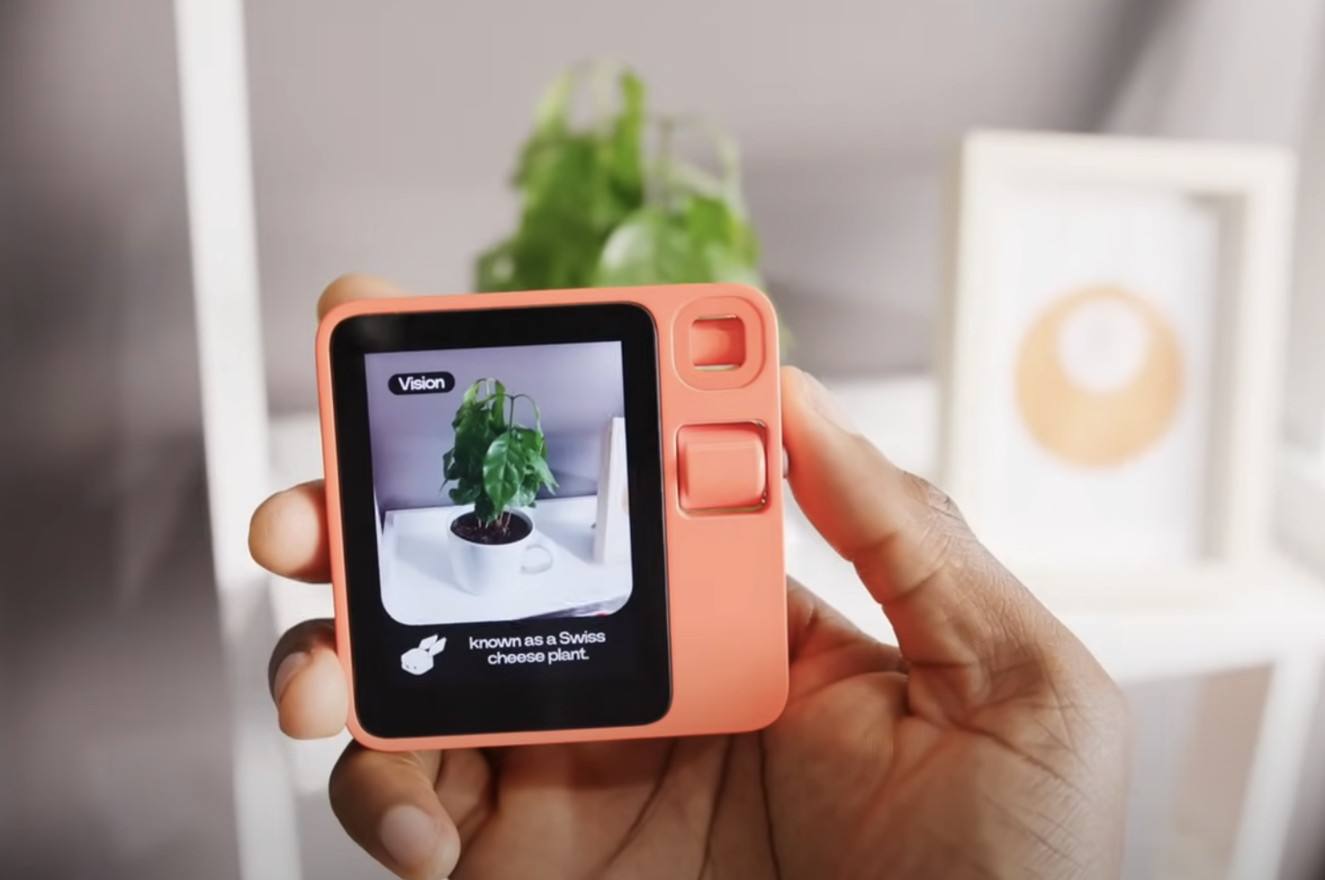

After this device was launched, the responses were mixed among people. Many tech reviewers found the initial version to be unfinished, unreliable, and largely inferior to a smartphone, while some long-term customers and community members find it to be a fun, innovative gadget that has improved significantly with software updates. It was regarded just as an initial stepping stone to the AI-powered phones. The large language model(LLM), which was used to operate the services of such large multifunctional apps without the help of a person, was found to be slow and laggy, and even at times, the responses provided by it were wrong.  
Supporters love the idea of a dedicated, distraction-free AI device and although they found the retro device looks nice, they said that ongoing and frequent software updates have to be addressed, including some major flaws, improving battery life, response times, and the reliability of features like translation.

**Activity 3:** Give 5 examples of External Cognition that you use in your daily life. In the past 10 years, which of the 5 examples have undergone the most change? And what are the changes that have happened?

Examples of external cognition that we use in our daily life are:

* One of the common examples is of PowerPoint presentation PPT slides, which we use to study as well as store information. PPT is used to explain topics and provide information visually. It helps as, instead of remembering all the points, we externalize them to store in information in the form of charts, images, and polls. This offloads the cognitive load as we see the structure instead of holding it mentally in our head
* Another common example is of Google Calendar, which we use to remember schedules, deadlines, and reminders. Instead of recalling all tasks, we rely on calendar entries. Due to the linking of your devices these days, if you book a meeting/appointment on your laptop, your phone will be able to automatically remind you about it.
* Google spreadsheets are another important tool being used for external cognition. When our teachers need to store marks, student names, or attendance details these days, Excel is used
* Alarms – Waking up early in the morning or when I take a quick nap in the day, I use alarm clock which is used to wake me up and keep control over time.
* Sticky Notes - I use them to remember small things when they happen or a make a list of the to-dos I have to do today.

Out of all the above-mentioned, I think that Excel spreadsheets have been the most involved one where people can store infinite amounts of information using se

**Activity 4:** Give 5 examples of Interface Metaphors that you like to use in the products (digital or physied cal) that you use regularly. Share screenshots and explain why you like them.  
1. The **Shopping Cart --**The first favored interface metaphor is the **"Shopping Cart,"** commonly used on e-commerce websites like Amazon or Target. This metaphor is effective because it perfectly mimics the real-world experience: a cart serves as an intuitive digital holding place for items while browsing.



2. Trash Can– It's a **two-stage metaphor** that gives me confidence. When I "**delete**" a file, it's not gone forever; it just goes into the trash. This mimics real life—I can throw something in the bin but "**rescue**" it later if I change my mind. I like that "**Emptying the trash**" is a separate, deliberate action, which **prevents permanent mistakes**.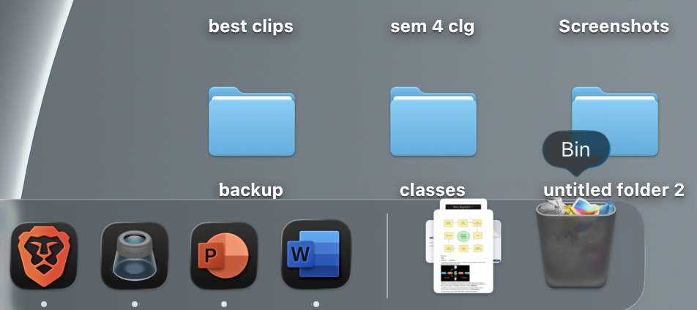

3. **File Folders –** Organizing files, images, and documents in separate folders. These folders can be changed with the images on there front so that it can be distinguished from each other.

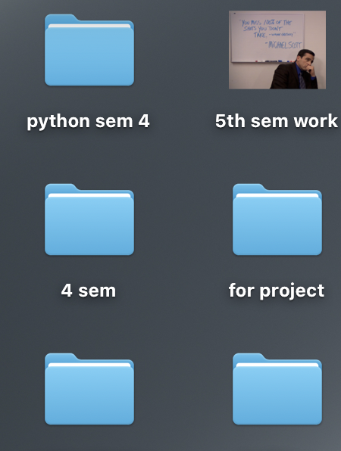

**4. The on-off button**

This is a perfect digital copy of a real-world

light switch. It's a binary choice: it is either "on" or "off."

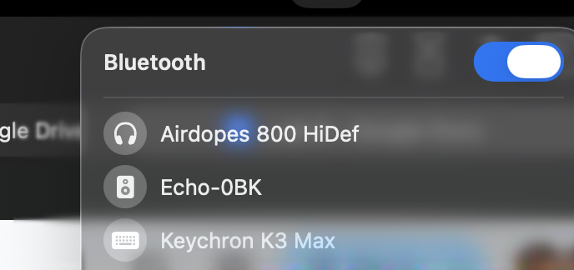

**4. Music controls.**

